Bidding for a Stretch of Days Off
There are different ways to bid a stretch of time off within a month. Below you will find several suggested bidding strategies.

- All or Nothing

This strategy is useful when you would like to have a stretch of dates off without the interruption of a day ON. Adding the All or Nothing criterion to the bid line instructs PBS to award all requested dates off, and PBS is unable to award all then award none of them. Checking this box indicates that if Denial Mode is triggered and PBS must deny this (or part of this) bid line, to remove the bid line entirely.
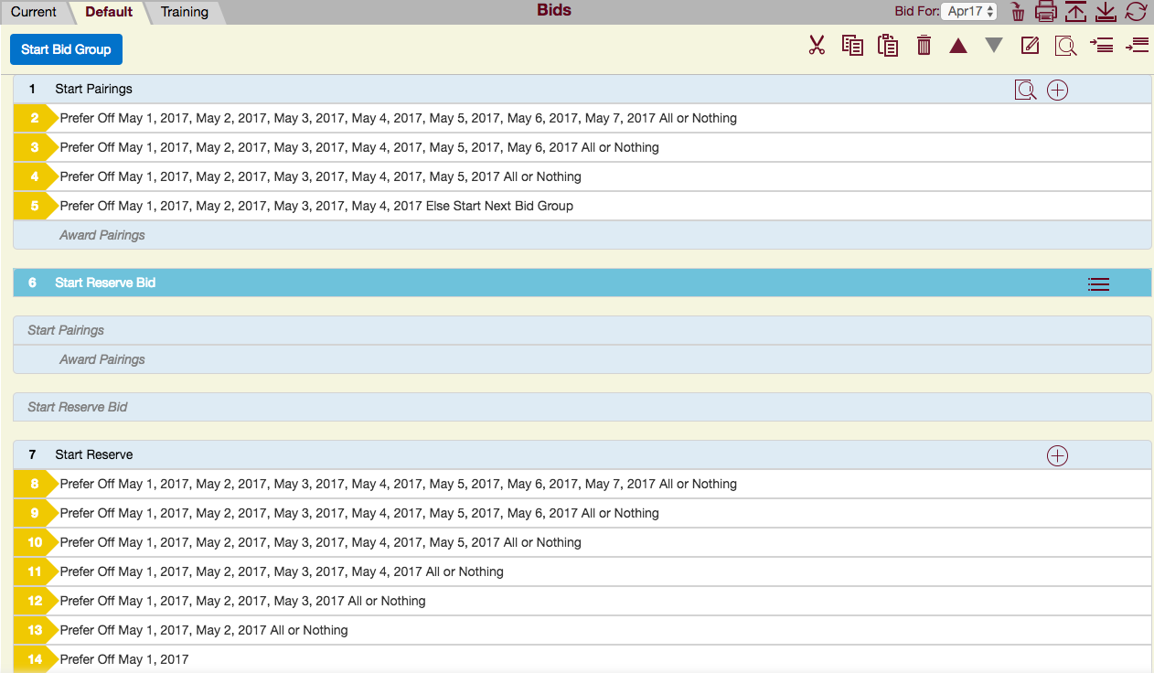
In the above image:
- Bid line number 2-4 and 8-14 are requesting dates off reducing the dates by one day, as the bid lines decrease in priority. Attaching the ‘All or Nothing’ criterion to the bid line will ensure that the set of dates off are not interrupted by any days ON.
- Bid line number 5, has the ‘Else Start Next Bid Group’ command attached to guide PBS out of this bid group, IF ALL of the dates on this bid line cannot be honoured.
- Bid line number 6, will instruct PBS to award from the Reserve Bid Group.
- Note: You could also instruct PBS to award from an additional ‘Pairings’ Bid Group.
- Within the Reserve Bid Group the Prefer Off bid requests are repeated again with the ‘All or Nothing’ command attached.
- Bid line number 14 does not have the ‘All or Nothing’ OR the ‘Else Start Next Bid Group’ command attached, as this is the final line.
Remember you must always take into consideration your overlapping (from one month into the next) 4/14 and 1/7 when plotting out your present months days off. You may waive BOTH blocking rules within your Pairings bid groups. However, you may only waive one of these two blocking rules within your Reserve bid group. Therefore, plotting your overlapping days off is very important so that you know which of the blocking rules should be waive, if any. Using a 'Merged Block Worksheet' will assist you with this task. (You may request this monthly revised worksheet from your PBS committee).

2. Set Condition “Consecutive Days Off”
This strategy is also useful when you would like to have a stretch of dates off without the interruption of a day ON. It is the same technique as above but using the Set Condition “Consecutive Days Off” command.
Please note that ‘Set Condition’ bid lines will not be read when PBS is awarding for Coverage.
All of the consecutive days off must fall within a specified Range Of Dates, or if no range is specified, the block month will be used as the range. Dates outside the block month will not be considered or used as part of the consecutive days off period. You may also attach ‘Else Start Next Bid Group’ should PBS not be able to fully honour the bid line. You may use “Day Off Between” or “Range of Dates”. See below for examples of using this technique with “Days Off Between”, no specified dates and “Range of Dates”.
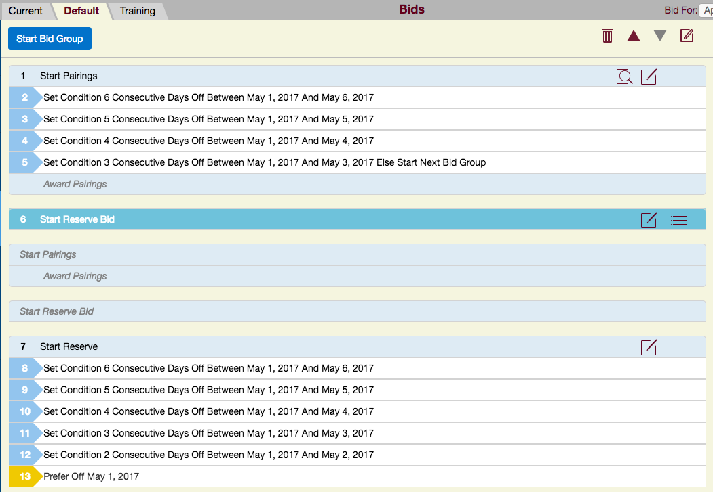
See next page for next example:

3. If you DO NOT have specific dates that you desire off then the ‘Set Condition Consecutive Days Off’ is the most useful.
- Again, if no specific dates are listed then the entire block month will be used as the Range of dates.
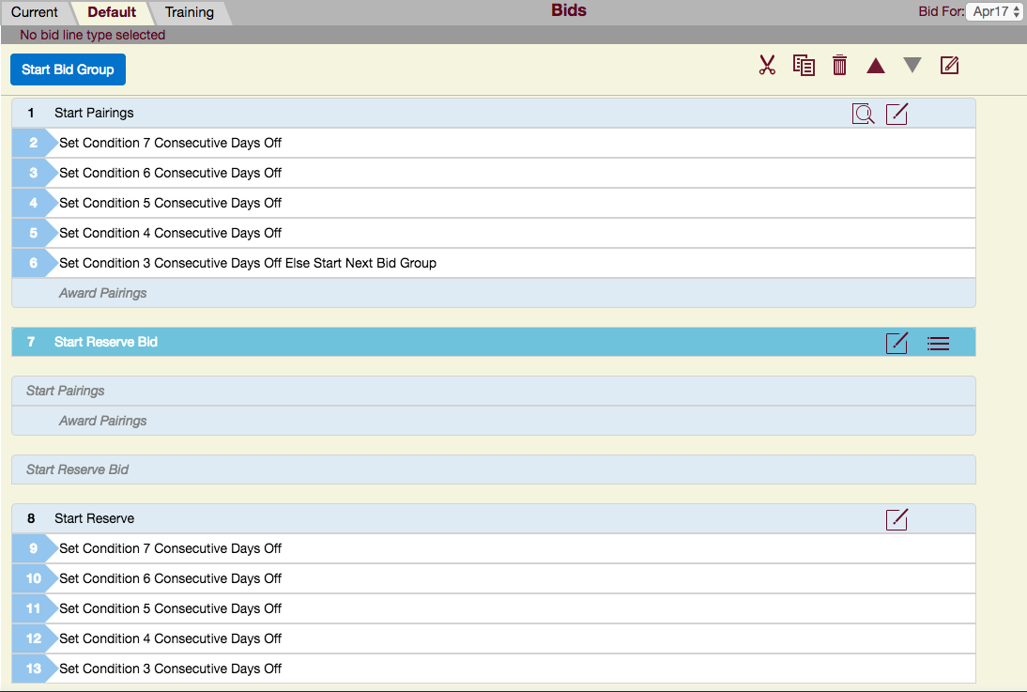
See next page for next example:

4. Range of Dates:
Another option within the Set Condition “Consecutive Days Off” command is to use Range of Dates.
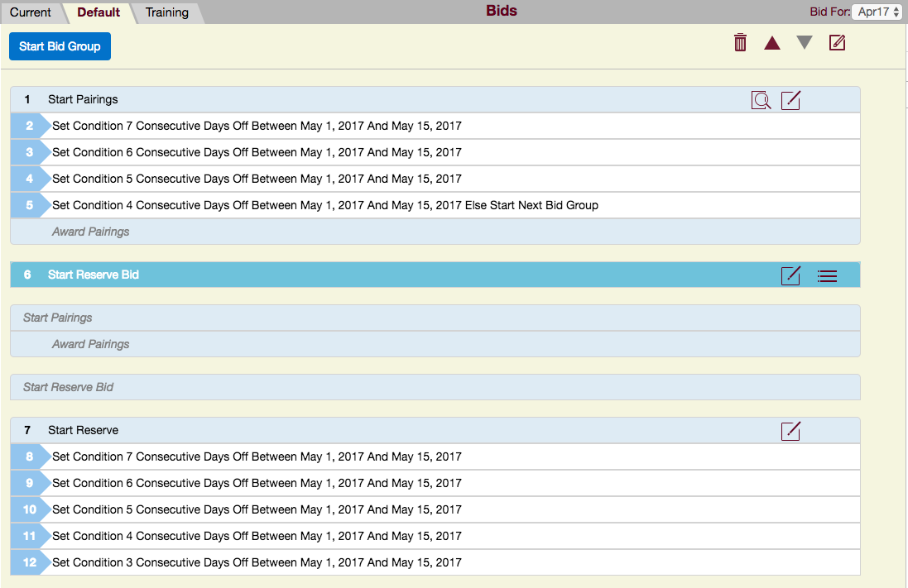
Caution:
In the above two scenarios, you may be awarded two stretches of days off,
e.g. in the example directly above, if bid line number 10 and 11 can both be honoured then you may end up with a 5 day stretch AND a 4 day stretch off within the same month.
Remember you must always take into consideration your overlapping (from one month into the next) 4/14 and 1/7 when plotting out your present months days off. You may waive BOTH blocking rules within your Pairings bid groups. However, you may only waive one of these two blocking rules within your Reserve bid group. Therefore, plotting your overlapping days off is very important so that you know which of the blocking rules you should waive, if any. Using a 'Merged Block Worksheet' will assist you with this task. You may request the updated worksheet from your PBS committee at anytime.

